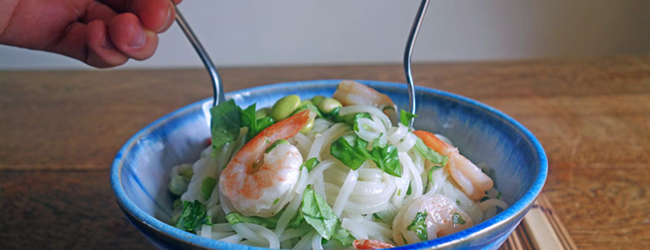

Prawn Noodle Salad with Yuzu Wasabi Dressing Recipe

If you fancy adding extras, for additional taste and crunch, there are further serving suggestions below.

**Preparation Time: 5 Minutes**

**Cooking Time: 5 Minutes**

**Serves 2**

* 150g cooked prawns
* 150g rice noodles
* 150g edamame beans, shelled
* a handful of basil leaves, chopped
* a handful of coriander leaves, chopped
* Optional extras : toasted sesame seeds, a handful of goji berries, chopped spring onions, finely chopped chilli, a few wedges of lime

For the Yuzu Wasabi Dressing

* 3 tbs yuzu juice, you can use 2 tbs lime and 1 tbs orange juice
* 1 1/2 tsp wasabi paste
* 3 tbs fish sauce
* 1 tbs maple syrup
* 1 tbs toasted sesame seed oil

Method

Place the noodles in a heatproof bowl and cover with boiling water. Leave for 5 mins, or until the noodles are tender. Drain them in a colander, then cool the noodles under cold running water and drain again. Return them to the bowl.

In a small bowl whisk together the ingredients for the dressing. Add a little more wasabi, if you fancy more of a kick.

Add the prawns, edamame beans and chopped herbs to the bowl of cooked noodles. Pour over the yuzu and wasabi dressing and toss to combine.

Serve chilled.